BANGALORE UNIVERSITY
"Jnana Bharathi", Bangalore: 560056

A Project Report on
“HEART DISEASE PREDICTION USING RANDOM FOREST”
SUBMITTED IN PARTIAL FULFILLMENT OF THE REQUIREMENT FOR THE AWARD OF DEGREE IN BACHELOR OF COMPUTER APPLICATIONS
Submitted By
SACHIN B A U03MG23S0047
ROHITH S U03MG23S0033
Under the guidance of
Ms. NAIDILE S. SARAGODU
Assistant Professor Department of Computer Applications
SEC, Kengeri.

DEPARTMENT OF COMPUTER APPLICATIONS
SURANA EVENING COLLEGE, KENGERI
(Affiliated to Bangalore University, Bangalore) CA-17, Stage I,
Kengeri Satellite Town,
Bengaluru, Karnataka 560060 2025-2026

“HEART DISEASE PREDICTION USING RANDOM FOREST”
A Project Report Submitted by SACHIN B A and ROHITH S Under the Guidance of
Ms. NAIDILE S. SARAGODU
Assistant Professor Department of Computer Applications
SEC, Kengeri.
In Partial Fulfillment of the Requirement for the Award of Degree of

Bachelor of Computer Applications

DEPARTMENT OF COMPUTER APPLICATIONS SURANA EVENING COLLEGE, KENGERI
(Affiliated to Bangalore University, Bangalore)
CA-17, Stage I, Kengeri Satellite Town, Bengaluru, Karnataka 560060 2025-2026

SURANA EVENING COLLEGE

(Affiliated to Bangalore University, Bangalore)

CA-17, Stage I, Kengeri Satellite Town, Bengaluru, Karnataka 560060

CERTIFICATE
Certified that the Project Report entitled " HEART DISEASE PREDICTION USING RANDOM FOREST " is a Bonafide work carried out by SACHIN B A bearing U03MG23S0047 and ROHITH S bearing U03MG23S0033 in partial fulfillment for the award of degree of Bachelor of Computer Applications of Bangalore University, Bangalore during the year 2025-2026. This work has been approved as it satisfies the academic requirements for the Project work prescribed for the Bachelor of Computer Applications Degree.

Examiner 1: ……………….

Examiner 2: ……………….
Signature of Guide | Signature of HOD | Signature of Principal
Ms. Naidile S. Saragodu | Ms. Naidile S. Saragodu | Dr. Guruprasad B G
Assistant Professor | Head of Dept. | Principal.
SEC, Kengeri. | SEC, Kengeri. | SEC, Kengeri

DECLARATION

We, hereby declare that the Project titled "Heart Disease Prediction using Random Forest" is completed, towards the partial fulfilment for the award of Bachelor of computer application of the Bangalore University, Bangalore, during 2025-2026. This has been compiled purely from the academic point of view and is therefore, presented in a true and sincere academic spirit. Contents of this report are based on our study and findings.

Date: …………. Signature of the students Place: Kengeri
SACHIN B A
U03MG23S0047

ROHITH S
U03MG23S0033

ACKNOWLEDGEMENT

The euphoria and satisfaction of the completion of the project will be incomplete without thanking the personalities responsible for this venture, which would not have been reality.
First and foremost, I extend my deepest thanks to Dr. Archana Surana Mam, Managing Trustee of Surana Educational Institutes, Bengaluru, for providing me with the opportunity and resources to pursue this project. Her vision and leadership have been a constant source of inspiration.
I would like to express our gratitude to Dr. Guruprasad B G, Principal of SECK for providing us congenial environment for studies related to Project.
I especially grateful to Ms. Naidile S. Saragodu, HOD, Department of Computer Applications for his continuous encouragement.
I express my deep sense of gratitude and profound feeling of admiration to our guide Ms. Naidile S. Saragodu, Assistant Professor, Department of Computer applications for his valuable suggestions, expert advice, unending support and constant guidance that helped me in completing the project work successfully.
Finally, I thank all those who have directly or indirectly helped us which made this work a reality.

SACHIN B A
U03MG23S0047

ROHITH S
U03MG23S0033

ABSTRACT

Heart disease is one of the leading causes of death worldwide, making early diagnosis and prediction essential for effective treatment and prevention. This project presents a Heart Disease Prediction System developed using Machine Learning techniques, specifically the Random Forest algorithm. The system analyzes various medical parameters such as age, sex, chest pain type, blood pressure, cholesterol level, fasting blood sugar, maximum heart rate, and other clinical attributes to predict the likelihood of heart disease in a patient.

The Random Forest classifier was chosen due to its high accuracy, robustness, and ability to handle complex datasets. The model was trained and tested using a heart disease dataset, where data preprocessing techniques such as handling missing values, feature selection, and data normalization were applied to improve performance. The trained model was then integrated into a user-friendly web application developed using Flask, allowing users to enter patient details and receive instant predictions.

The system aims to assist healthcare professionals and individuals by providing a reliable decision-support tool for early detection of heart disease. Experimental results demonstrate that the Random Forest model achieves high prediction accuracy and performs effectively compared to other traditional machine learning algorithms. This project highlights the potential of artificial intelligence and machine learning in improving healthcare services and supporting preventive medical diagnosis.

TABLE OF CONTENT

Sl. No. | Content | Page No.
1 | Chapter 1 – Introduction | 9
1.1 | Introduction | 10
1.2 | Background of the Project | 11
1.3 | Project Overview | 12
1.4 | Objectives of the Project | 14
1.5 | Scope of the Project | 15
1.6 | Expected Outcomes | 16
1.7 | User Instruction | 17
1.8 | Features of System | 18
1.9 | Future Scope of the Project | 20
1.10 | Aim and Benefit of Project | 21
2 | Chapter 2 – Software and Hardware Requirements | 22
2.1 | Hardware Requirements | 23
2.2 | Software Requirements | 24
3 | Chapter 3 – Project Technologies | 25
3.1 | Frontend Technologies | 26
3.2 | Backend Technologies | 27
3.3 | Machine Learning Technology | 28
3.4 | Dataset Description | 29
3.5 | Development Tools and Environment | 32
4 | Chapter 4 – Existing System | 33
4.1 | Existing System | 34
4.2 | Limitations of Existing System | 35
5 | Chapter 5 – Proposed System | 37
5.1 | Proposed System | 38
5.2 | Advantages of Proposed System | 39
5.3 | Methodology Followed | 40
6 | Chapter 6 – System Analysis | 42
6.1 | Block Diagram | 43
6.2 | Flow Chart | 44
6.3 | System Architecture | 46
6.4 | Module Description | 47
7 | Chapter 7 – System Design | 48
7.1 | Login and Authentication Module | 49
7.2 | Prediction Input Module | 51
7.3 | Risk Result and Reporting Module | 54
8 | Chapter 8 – Machine Learning Model | 56
8.1 | Dataset and Preprocessing | 57
8.2 | Model Training and Evaluation | 59
9 | Chapter 9 – Screenshot And Source Code | 61
9.1 | Screenshot | 62
9.2 | Source Code | 65
10 | Chapter 10 – Testing And Validation | 69
10.1 | Unit testing | 70
10.2 | Integration Testing | 71
11 | Chapter 11 – Conclusion | 72
12 | Chapter 12 – Future Enhancements | 74
13 | Chapter 13 – Bibliography | 76

CHAPTER- 1
INTRODUCTION

1.1 Introduction
Heart disease is one of the most serious health challenges faced by people across the world. According to various healthcare reports, cardiovascular diseases account for millions of deaths every year and continue to be a major concern for healthcare organizations, governments, and medical professionals. The increasing prevalence of unhealthy lifestyles, poor dietary habits, smoking, alcohol consumption, obesity, stress, and lack of physical activity has significantly contributed to the rise in heart-related diseases.
Early diagnosis of heart disease is essential because many cardiovascular conditions develop gradually and may not exhibit visible symptoms during the initial stages. Patients often become aware of the disease only after severe complications such as heart attacks, strokes, or cardiac arrest occur. Therefore, there is a growing need for intelligent systems that can identify potential risks before the disease reaches a critical stage.

The rapid advancement of Artificial Intelligence (AI) and Machine Learning (ML) has introduced new opportunities for improving healthcare services. Machine learning algorithms can analyze large volumes of medical data, discover hidden patterns, and provide accurate predictions based on historical records. These technologies help healthcare professionals make informed decisions and improve patient care.

The Heart Disease Prediction System uses the Random Forest Machine Learning Algorithm to analyze patient health information and predict whether an individual is likely to suffer from heart disease. By evaluating important health parameters such as age, blood pressure, cholesterol level, heart rate, chest pain type, and other medical indicators, the system generates a prediction that assists doctors and patients in understanding cardiovascular risks.

The proposed system provides a fast, efficient, and reliable approach to heart disease prediction. It reduces the dependency on manual diagnosis procedures and helps healthcare professionals identify high-risk patients at an early stage. This project demonstrates how machine learning can contribute to preventive healthcare and improve overall medical outcomes.
1.2 Background
Cardiovascular diseases have been recognized as one of the leading causes of death worldwide for several decades. Medical researchers and healthcare professionals continuously work toward developing methods for early diagnosis and treatment to reduce mortality rates.

Traditional methods of heart disease diagnosis involve physical examinations, laboratory tests, ECG analysis, angiography, stress tests, and expert clinical evaluation. While these methods are effective, they often require specialized equipment, significant financial resources, and experienced medical practitioners. In many cases, diagnosis can be time-consuming, delaying preventive treatment.

With the emergence of healthcare data analytics, researchers have started applying machine learning techniques to medical datasets. Machine learning algorithms can process vast amounts of patient information and identify complex relationships between risk factors and disease occurrence.

Among various machine learning techniques, Random Forest has gained popularity due to its high accuracy, robustness, and ability to handle complex datasets. Random Forest combines multiple decision trees to improve prediction performance and minimize overfitting. This makes it particularly suitable for healthcare prediction systems where accuracy and reliability are critical.

The Heart Disease Prediction project is developed based on these advancements in machine learning and healthcare analytics. It leverages historical patient data to build a predictive model capable of assisting healthcare professionals in diagnosing heart disease more effectively.

1.3 Project Overview
The Heart Disease Prediction System Using Random Forest is an Artificial Intelligence and Machine Learning-based healthcare application designed to predict the likelihood of heart disease in individuals based on their medical parameters. The primary objective of the project is to assist healthcare professionals and patients by providing an early risk assessment of cardiovascular disease through automated prediction techniques. The system utilizes historical healthcare data and machine learning algorithms to analyze patient information and generate accurate predictions regarding the presence or absence of heart disease.
The project combines Machine Learning, Data Analysis, and Web Development technologies to create an intelligent and user-friendly healthcare solution. The application is developed using the Python programming language and the Flask framework, while the Random Forest algorithm serves as the core prediction model. The trained machine learning model is integrated into a web-based application that allows users to enter patient health details and instantly receive prediction results.
The system operates through a series of well-defined modules. Initially, the Data Collection Module gathers patient information such as age, gender, blood pressure, cholesterol level, fasting blood sugar, chest pain type, electrocardiographic results, maximum heart rate, exercise-induced angina, and other medical attributes. These parameters are commonly used by medical practitioners to assess cardiovascular health and are essential for accurate disease prediction.
After data collection, the information passes through the Data Preprocessing Module, where the dataset is cleaned and prepared for machine learning operations. This stage involves handling missing values, removing duplicate records, treating outliers, normalizing numerical values, and converting categorical data into machine-readable formats. Proper preprocessing improves the quality of data and enhances the performance of the prediction model.
The next stage involves Feature Selection, where the most significant health indicators influencing heart disease prediction are identified and selected. This process helps reduce computational complexity, eliminate irrelevant attributes, and improve prediction accuracy. By focusing on important features, the machine learning model becomes more efficient and reliable.
The selected data is then used in the Model Training Module, where the Random Forest algorithm is trained using historical healthcare records. The dataset is divided into training and testing sets, with approximately 80% used for training and 20% reserved for testing. The algorithm learns patterns from the training data and develops a predictive model capable of classifying patients based on their heart disease risk.
Once the model is trained, the Prediction Module accepts new patient data and generates predictions regarding heart disease risk. The Random Forest model analyzes the provided health parameters and determines whether the patient is likely to have heart disease. The prediction results are generated quickly and accurately, enabling timely healthcare interventions. According to the project synopsis, the system achieves an accuracy of approximately 80–85%, making it a reliable tool for preliminary risk assessment.
The project also includes a User Interface Module, which provides an easy-to-use platform for users to enter health information and view prediction results. The web-based interface has been designed to be simple, interactive, and accessible, allowing both medical professionals and non-technical users to operate the system without difficulty. Additionally, the system includes report generation capabilities that allow users to save or print prediction results for future reference.
To ensure the reliability of predictions, the Evaluation Module measures the performance of the machine learning model using various metrics such as accuracy, precision, recall, F1-score, and confusion matrix analysis. These evaluation techniques help validate the effectiveness of the model and ensure consistent performance across different datasets.
The overall project demonstrates the practical application of Artificial Intelligence in healthcare by providing a fast, accurate, and cost-effective method for heart disease prediction. It supports early diagnosis, assists healthcare professionals in decision-making, and encourages preventive healthcare practices. By integrating machine learning algorithms with modern web technologies, the Heart Disease Prediction System serves as an intelligent healthcare solution capable of improving patient outcomes and reducing the risk of severe cardiovascular complications.

1.4 Objectives of the Project

The primary objective of the Heart Disease Prediction Using Random Forest project is to develop an intelligent healthcare system that can accurately predict the risk of heart disease using machine learning techniques. The project aims to assist healthcare professionals and patients by providing early identification of cardiovascular risks, thereby enabling timely medical intervention and preventive healthcare measures. The system utilizes patient health data and advanced analytical methods to generate reliable predictions that support better medical decision-making.

Main Objectives of the Project
- To develop an intelligent Heart Disease Prediction System using Machine Learning techniques.
- To predict the risk of heart disease accurately using the Random Forest Algorithm.
- To assist healthcare professionals in making faster and better clinical decisions.
- To enable early detection of heart disease and reduce the risk of severe complications.
- To analyze patient health parameters such as age, blood pressure, cholesterol, blood sugar, and heart rate for disease prediction.
- To automate the prediction process and minimize manual analysis.
- To provide a user-friendly web-based application for easy data entry and result generation.
- To improve the accuracy and reliability of heart disease diagnosis through machine learning.
- To support preventive healthcare by identifying high-risk patients at an early stage.
- To reduce the time and cost involved in preliminary medical diagnosis.
- To evaluate the performance of the prediction model using accuracy, precision, recall, and F1-score metrics.
- To demonstrate the practical application of Artificial Intelligence and Machine Learning in Healthcare.
- To create a scalable system that can be enhanced in the future for predicting other diseases.
- To improve healthcare awareness and encourage timely medical consultation.

1.5 SCOPE OF THE PROJECT
The scope of the Heart Disease Prediction Using Random Forest project lies in the application of Artificial Intelligence and Machine Learning techniques to the healthcare sector for early disease prediction and risk assessment. The system is designed to analyze patient medical information and predict the likelihood of heart disease based on various health parameters. It provides a practical and efficient solution that can assist healthcare professionals and individuals in identifying cardiovascular risks before they become severe.
The project covers the collection, preprocessing, analysis, and prediction of healthcare data using machine learning algorithms. It utilizes important patient attributes such as age, gender, chest pain type, blood pressure, cholesterol level, fasting blood sugar, electrocardiographic results, maximum heart rate, exercise-induced angina, and other medical indicators to generate prediction results. The system processes these parameters and provides an instant assessment of heart disease risk through a web-based application.
The development of a user-friendly interface that enables users to enter medical information easily and obtain prediction results quickly. The application can be used by healthcare professionals, medical students, researchers, and individuals interested in monitoring their cardiovascular health. The system serves as a decision-support tool by providing additional insights that can assist doctors in diagnosis and treatment planning.
Furthermore, the project demonstrates the practical implementation of Machine Learning algorithms in real-world healthcare applications. It highlights the use of the Random Forest algorithm for classification and prediction tasks and provides valuable experience in data preprocessing, feature selection, model training, evaluation, and deployment. The project also creates opportunities for future enhancements such as integrating real-time patient monitoring systems, cloud-based healthcare services, mobile applications, and multi-disease prediction platforms.
1.6 EXPECTED OUTCOMES
The Heart Disease Prediction Using Random Forest project is expected to provide an efficient and intelligent solution for predicting the risk of heart disease based on patient health data. The system is designed to assist healthcare professionals and individuals by generating accurate predictions using machine learning techniques. By analyzing various medical parameters, the application can identify potential cardiovascular risks at an early stage, enabling timely medical intervention and preventive healthcare measures.
One of the primary expected outcomes of the project is the development of a highly accurate machine learning model capable of predicting heart disease risk with reliable performance. The Random Forest algorithm is expected to classify patient data effectively and provide prediction results that support clinical decision-making. The system will help reduce the time required for preliminary diagnosis and improve the efficiency of healthcare services.
The project is also expected to facilitate the early detection of heart-related problems, allowing patients to take necessary precautions before the condition becomes severe. Through timely risk assessment, users can adopt healthier lifestyles, undergo further medical evaluation, and reduce the chances of serious cardiovascular complications. The system aims to increase awareness about heart health and encourage preventive healthcare practices among individuals.
Another expected outcome is the creation of a user-friendly web application that enables easy data entry and quick access to prediction results. The interface will allow healthcare professionals and general users to interact with the system conveniently, making the technology accessible even to those with limited technical knowledge. The project is expected to demonstrate how Artificial Intelligence and Machine Learning can be successfully integrated into healthcare applications to improve patient care and medical decision-making.
Additionally, the project is expected to contribute to the advancement of intelligent healthcare systems by providing a scalable framework that can be extended in the future for predicting other diseases. The successful implementation of this system will showcase the potential of machine learning in healthcare analytics and support further research in disease prediction and medical data analysis.

1.7 User Instructions
The system is designed to be simple and user-friendly.
Step 1: User Login
The user logs into the application using authorized credentials.

Step 2: Enter Patient Information
The user enters medical information such as:
- Age
- Sex
- Chest Pain Type
- Blood Pressure
- Cholesterol Level
- Blood Sugar
- Heart Rate
- Exercise-Induced Angina
- ST Depression
- Other Health Parameters

Step 3: Submit Data
After entering all required details, the user submits the form.

Step 4: Prediction Processing
The Random Forest model processes the input data.

Step 5: Display Result
The system displays whether the patient is likely to have heart disease or not.

Step 6: Generate Report
Prediction reports can be viewed and stored for future reference.

Step 7: Logout
The user safely logs out after completing the prediction process.

1.8 Features of System
The Heart Disease Prediction System incorporates several advanced features that make it an effective and user-friendly healthcare application. The system is designed to analyze patient health data, predict heart disease risk, and assist in medical decision-making through the use of Machine Learning and Artificial Intelligence technologies.

Key Features of the System
- Heart Disease Prediction: Predicts the likelihood of heart disease based on patient medical information using the Random Forest Algorithm.
- Machine Learning-Based Analysis: Utilizes Artificial Intelligence and Machine Learning techniques to analyze health data and generate accurate predictions.
- Early Risk Detection: Identifies potential heart disease risks at an early stage, enabling timely medical intervention and preventive care.
- User-Friendly Interface: Provides a simple and interactive web-based interface that allows users to enter health information easily and obtain results quickly.
- Fast Prediction Results: Generates prediction outcomes within seconds, reducing the time required for preliminary diagnosis.
- Data Preprocessing Capability: Handles data cleaning, normalization, and preparation to improve prediction accuracy and model performance.
- High Prediction Accuracy: Uses the Random Forest algorithm, which is known for its reliability, robustness, and high classification accuracy.
- Input Validation: Validates user-entered data to ensure correct and meaningful inputs before processing.
- Secure User Authentication: Supports login and session management features to restrict unauthorized access and protect user information.
- Report Generation: Allows users to generate and download prediction reports for future reference and documentation.
- Healthcare Decision Support: Assists doctors and healthcare professionals by providing additional insights during diagnosis and treatment planning.
- Efficient Data Analysis: Processes multiple health parameters simultaneously and identifies relationships among risk factors.
- Scalable Architecture: Designed to support future enhancements such as additional disease prediction modules and advanced analytics.
- Web-Based Accessibility: Can be accessed through standard web browsers without requiring specialized software installation.
- Performance Evaluation: Evaluates model effectiveness using metrics such as accuracy, precision, recall, F1-score, and confusion matrix analysis.

1.9 Future Scope of the Project
The Heart Disease Prediction Using Random Forest project has significant potential for future enhancements and expansion. As healthcare technologies continue to evolve, the system can be improved by incorporating advanced Artificial Intelligence techniques, larger datasets, and real-time health monitoring capabilities. The current system serves as a foundation for intelligent healthcare applications and can be extended to provide more comprehensive medical services.

One of the major future enhancements is the integration of Deep Learning and Advanced Machine Learning Algorithms to further improve prediction accuracy and handle more complex healthcare datasets. The system can also be trained using larger and more diverse medical datasets collected from hospitals and healthcare organizations, which will increase its reliability and effectiveness in real-world scenarios.

The project can be expanded into a multi-disease prediction platform capable of predicting other health conditions such as diabetes, kidney disease, liver disease, stroke, hypertension, and cancer. This would transform the application into a comprehensive healthcare decision-support system that assists in the diagnosis of multiple diseases using a single platform.

Another important future scope is the development of a mobile application for Android and iOS devices. A mobile-based solution would allow users to access the prediction system anytime and anywhere, making healthcare services more convenient and accessible. Integration with wearable devices such as smartwatches and fitness trackers can enable real-time monitoring of health parameters like heart rate, blood pressure, and physical activity levels.

1.10 Aim and Benefits of the Project
Aim of the Project
The main aim of the Heart Disease Prediction Using Random Forest project is to develop an intelligent healthcare system that can accurately predict the risk of heart disease using Machine Learning techniques. The project aims to analyze patient health data and provide early detection of cardiovascular diseases, thereby assisting healthcare professionals and individuals in making informed medical decisions. By utilizing the Random Forest algorithm, the system seeks to improve prediction accuracy, reduce diagnostic time, and support preventive healthcare practices. The project also aims to demonstrate the practical application of Artificial Intelligence in the healthcare sector by creating a user-friendly web-based platform that enables quick and reliable heart disease risk assessment.

Benefits of the Project
The Heart Disease Prediction System offers numerous benefits to both healthcare professionals and patients. One of the major benefits is the early detection of heart disease risk, which allows patients to seek timely medical treatment and adopt preventive measures before the condition becomes severe. The system helps reduce the chances of serious cardiovascular complications by identifying potential health risks at an early stage.
Another important benefit is the improvement of healthcare decision-making. The prediction results generated by the system can assist doctors and medical practitioners in evaluating patient conditions more effectively and making better clinical decisions. The system serves as a supportive tool that complements traditional diagnostic methods.
The project also provides fast and automated prediction results, reducing the time required for preliminary diagnosis. Unlike conventional methods that may involve multiple tests and lengthy analysis, the machine learning model processes patient data quickly and generates instant results.
The use of the Random Forest Algorithm enhances prediction accuracy and reliability, making the system a dependable solution for heart disease risk assessment. The application is also designed with a user-friendly interface, enabling users to enter medical information easily and access prediction results without technical expertise.

CHAPTER- 2
SOFTWARE & HARDWARE REQUIREMENTS

2.1 HARDWARE REQUIREMENTS
Hardware requirements define the physical components necessary for the development, testing, and deployment of the Heart Disease Prediction System. Since the project involves machine learning model training, data processing, and web application execution, the system requires a computer with adequate processing power and memory. The hardware configuration selected for this project ensures smooth operation of machine learning algorithms, efficient data analysis, and reliable execution of the web application.
The project has been designed to run on standard personal computers and does not require specialized hardware. During the development phase, the system was tested on a computer with sufficient RAM, storage space, and internet connectivity to support Python libraries and machine learning operations. A higher hardware configuration can improve training speed and overall system performance, especially when working with larger healthcare datasets.

Hardware Component | Specification
Processor (CPU) | Intel Core i3 / AMD Ryzen 3 or Higher
RAM | Minimum 4 GB (8 GB Recommended)
Storage | Minimum 5 GB Free Space
Storage Type | SSD Recommended
Display Resolution | 1366 × 768 or Higher
Input Devices | Keyboard and Mouse
Network | Internet Connection (for Google Fonts loading)
System Architecture | 64-bit System

2.2 SOFTWARE REQUIREMENTS
Software requirements specify the programming languages, frameworks, tools, libraries, and operating systems used in the development of the Heart Disease Prediction System. The project utilizes open-source technologies that provide flexibility, reliability, and scalability for machine learning and web application development.

The software environment consists of Python for programming, Flask for web application development, Scikit-Learn for machine learning implementation, and supporting libraries such as Pandas, NumPy, and Matplotlib for data processing and visualization.

Software / Technology | Purpose
Python 3.8+ | Backend development and machine learning
Flask 2.x | Web application framework and routing
scikit-learn | Random Forest model training and GridSearchCV
pandas | Data processing and DataFrame creation
numpy | Numerical computations
joblib | Model serialization and loading
ReportLab | PDF medical report generation
HTML5 / CSS3 | Frontend structure and styling
VS Code / Jupyter Notebook | Development environment
Web Browser (Chrome / Firefox) | Application interface
OS | Windows10 / 11

CHAPTER- 3
PROJECT TECHNOLOGIES

3.1 Frontend Technologies
Frontend technologies are responsible for creating the visual interface through which users interact with the Heart Disease Prediction System. The frontend is designed to provide a simple, responsive, and user-friendly environment for entering patient information and viewing prediction results.

The project uses HTML (HyperText Markup Language) to create the structure and layout of web pages. HTML is used to design forms, buttons, labels, input fields, and other webpage elements required for user interaction. It serves as the foundation of the application's user interface and ensures compatibility across different web browsers.

CSS (Cascading Style Sheets) is used to improve the appearance and presentation of the web pages. CSS controls colors, fonts, spacing, alignment, and responsive layouts, making the application visually appealing and easy to use. It helps create a professional-looking interface that enhances the overall user experience.

JavaScript is utilized to provide dynamic functionality and client-side validation. It enables interactive features such as form validation, error checking, and real-time user interactions. JavaScript improves usability by ensuring that users enter valid data before submitting information to the server.

The project also employs Bootstrap, a popular frontend framework that helps create responsive and mobile-friendly web pages. Bootstrap provides pre-designed components and layouts that simplify interface development and ensure compatibility across different devices and screen sizes.

3.2 Backend Technologies
The backend technologies are responsible for handling application logic, data processing, machine learning operations, and communication between the user interface and prediction model.
The primary programming language used in this project is Python. Python is widely used in Artificial Intelligence and Machine Learning applications due to its simplicity, readability, and extensive library support. It serves as the core language for implementing data preprocessing, model training, and prediction functionalities.
The project utilizes the Flask Framework, which is a lightweight Python-based web framework used for developing web applications. Flask manages routing, form handling, session management, authentication, and integration of machine learning models with the web interface. Its simplicity and flexibility make it ideal for deploying machine learning applications.
For machine learning implementation, the project uses the Scikit-Learn library. Scikit-Learn provides tools for data preprocessing, model training, testing, evaluation, and prediction. The Random Forest algorithm used in this project is implemented through this library.
The Pandas library is used for data manipulation and preprocessing. It provides powerful data structures such as DataFrames that simplify data cleaning, transformation, and analysis tasks. Pandas plays a crucial role in preparing healthcare data for machine learning operations.
NumPy is used for numerical and mathematical computations. It supports efficient matrix operations, statistical calculations, and array manipulations that are essential for machine learning algorithms.
The project also utilizes Joblib for saving and loading trained machine learning models. This allows the prediction model to be stored permanently and reused without retraining, thereby improving application performance and reducing processing time.

3.3 Machine Learning Technology
Machine Learning is the core technology used in the Heart Disease Prediction System. The project employs the Random Forest Algorithm, which is an ensemble learning technique used for classification and prediction tasks. Random Forest creates multiple decision trees using different subsets of training data and combines their outputs through majority voting to generate the final prediction.
The algorithm is highly effective in handling healthcare datasets because it reduces overfitting, improves prediction accuracy, and performs well with both numerical and categorical data. The trained Random Forest model analyzes patient health parameters and predicts whether a patient is likely to have heart disease.
Machine learning enables the system to identify patterns and relationships within medical data that may not be easily recognized through traditional analysis. This capability makes the prediction process more efficient, reliable, and suitable for healthcare applications.

3.4 DATASET DESCRIPTION
The performance and accuracy of any Machine Learning model largely depend on the quality and relevance of the dataset used for training and testing. In the Heart Disease Prediction System, a healthcare dataset containing various patient medical attributes is used to train the Random Forest algorithm. The dataset consists of historical patient records that include several clinical and physiological parameters commonly associated with cardiovascular diseases. These attributes help the machine learning model identify patterns and relationships that indicate the presence or absence of heart disease.
The dataset used in this project contains information collected from patients with different health conditions. Each record represents a patient's medical profile and includes features such as age, gender, chest pain type, resting blood pressure, cholesterol level, fasting blood sugar, electrocardiographic results, maximum heart rate achieved, exercise-induced angina, ST depression, slope of the peak exercise ST segment, number of major blood vessels, and thalassemia status. The target attribute indicates whether the patient is likely to have heart disease or not.
Before training the machine learning model, the dataset undergoes a preprocessing phase where missing values, duplicate records, and inconsistencies are handled appropriately. Data cleaning and feature selection techniques are applied to improve data quality and enhance prediction accuracy. The processed dataset is then divided into training and testing sets, with approximately 80% of the data used for training and 20% used for testing the model's performance.
The dataset provides valuable medical information that enables the Random Forest algorithm to learn patterns related to heart disease risk factors. By analyzing these factors, the system can generate accurate predictions and support healthcare professionals in making informed decisions regarding patient health.

Dataset Attributes
Attribute | Description
Age | Age of the patient in years
Sex | Gender of the patient (1 = Male, 0 = Female)
CP | Chest Pain Type
Trestbps | Resting Blood Pressure (mm Hg)
Chol | Serum Cholesterol Level (mg/dl)
FBS | Fasting Blood Sugar
Restecg | Resting Electrocardiographic Results
Thalach | Maximum Heart Rate Achieved
Exang | Exercise-Induced Angina
Oldpeak | ST Depression Induced by Exercise
Slope | Slope of Peak Exercise ST Segment
CA | Number of Major Blood Vessels Colored by Fluoroscopy
Thal | Thalassemia Status
Target | Heart Disease Prediction (1 = Disease, 0 = No Disease)

Dataset Advantages
The dataset contains multiple health-related features that significantly influence cardiovascular conditions, making it suitable for heart disease prediction. It provides sufficient information for training machine learning models and enables accurate classification of patients based on disease risk. The dataset is structured, easy to process, and widely used in healthcare analytics research, making it an ideal choice for developing predictive healthcare systems.

Importance of the Dataset
The dataset serves as the foundation of the Heart Disease Prediction System. The accuracy and reliability of the machine learning model depend on the quality of the data used during training. By utilizing relevant medical attributes and applying appropriate preprocessing techniques, the dataset helps the Random Forest algorithm learn meaningful patterns and generate reliable predictions regarding heart disease risk.

3.5 Development Tools and Environment
Several software tools are used during the development and testing of the Heart Disease Prediction System. Jupyter Notebook is used as the primary code editor for writing and managing source code. is utilized for dataset analysis, model training, visualization, and experimentation with machine learning algorithms.
The project is developed and tested on the Windows Operating System, which provides compatibility with Python libraries and web development tools. Web browsers such as Google Chrome, Microsoft Edge, and Mozilla Firefox are used to access and test the application interface.
The machine learning model is trained using Python libraries and then integrated into the Flask application for deployment. This development environment provides flexibility, scalability, and ease of maintenance.

CHAPTER 4
EXISTING SYSTEM

4.1 EXISTING SYSTEM
The existing system for diagnosing heart disease primarily depends on traditional medical procedures and the expertise of healthcare professionals. In conventional healthcare environments, doctors analyze patient symptoms, medical history, physical examinations, laboratory test reports, electrocardiograms (ECG), echocardiograms, stress tests, and other diagnostic results before making a final diagnosis. This process requires significant medical knowledge, time, and resources to accurately determine whether a patient is suffering from heart disease.
In the traditional approach, patients must undergo multiple medical examinations and diagnostic tests to assess their cardiovascular health. The collected information is manually reviewed and interpreted by healthcare professionals. Although these methods provide reliable results, they can be time-consuming and expensive, particularly when specialized tests and consultations are required. In many cases, patients may experience delays in diagnosis due to the lengthy evaluation process, which can affect the effectiveness of treatment and increase the risk of serious complications.
Another limitation of the existing system is its heavy dependence on human expertise and judgment. Different healthcare professionals may interpret diagnostic information differently, leading to variations in diagnosis and treatment recommendations. Human errors, incomplete medical records, and subjective decision-making can sometimes affect the accuracy and consistency of the diagnostic process. Furthermore, traditional diagnosis methods may not always be capable of identifying hidden patterns or complex relationships among multiple health parameters.
The increasing number of patients and the growing burden on healthcare systems also present challenges for traditional diagnosis methods. Manual analysis of large volumes of patient data requires considerable effort and may result in increased workload for healthcare professionals. This can lead to delays in patient evaluation and reduce overall healthcare efficiency. In addition, healthcare facilities in rural or underdeveloped regions may have limited access to specialized diagnostic equipment and experienced cardiologists, making early diagnosis more difficult.
The existing system also lacks automation and predictive capabilities. Traditional methods focus primarily on identifying diseases after symptoms appear rather than predicting the likelihood of disease occurrence in advance. As a result, opportunities for early intervention and preventive healthcare may be missed. Patients who are at high risk of developing heart disease may remain undetected until significant health complications occur.

4.2 Limitations of the Existing System

- Diagnosis depends heavily on the experience and expertise of doctors.
- Requires multiple laboratory tests and medical examinations.
- Time-consuming diagnostic process.
- Higher healthcare costs due to extensive testing procedures.
- Possibility of human errors and subjective judgments.
- Lack of automated disease prediction capabilities.
- Limited support for early detection and preventive healthcare.
- Difficulties in managing and analyzing large healthcare datasets.
- Delays in diagnosis may affect treatment effectiveness.
- Limited accessibility in remote and rural healthcare settings.

Existing System Workflow

Patient Registration
↓
Medical Examination
↓
Laboratory Tests and Reports
↓
Doctor's Analysis and Evaluation
↓
Diagnosis of Heart Disease
↓
Treatment Recommendation

Drawbacks of the Existing System

The traditional approach to heart disease diagnosis, while medically established, has several drawbacks. It often requires considerable time, financial resources, and specialized medical expertise. The lack of automated prediction mechanisms limits the ability to identify high-risk patients at an early stage. Furthermore, manual analysis may not effectively utilize the growing amount of healthcare data available today. These challenges highlight the need for intelligent healthcare systems that can assist medical professionals by providing faster, more accurate, and data-driven predictions.

CHAPTER 5
PROPOSED SYSTEM

5.1 Proposed System

The proposed system, Heart Disease Prediction Using Random Forest, is an intelligent healthcare application developed to predict the risk of heart disease using Machine Learning techniques. The system is designed to analyze patient medical data and provide accurate predictions regarding the presence or absence of heart disease. Unlike traditional diagnosis methods that rely heavily on manual examination and expert interpretation, the proposed system automates the prediction process using Artificial Intelligence and Data Analytics.
The application collects important health parameters such as age, gender, chest pain type, resting blood pressure, cholesterol level, fasting blood sugar, electrocardiographic results, maximum heart rate achieved, exercise-induced angina, ST depression, slope value, number of major blood vessels, and thalassemia status. These medical attributes are processed through a trained Random Forest model that predicts the likelihood of heart disease. The system is integrated into a web-based application developed using Flask, allowing users to enter medical information and receive prediction results instantly.
The proposed system serves as a decision-support tool for healthcare professionals by providing data-driven insights that assist in diagnosis and treatment planning. It also helps individuals monitor their cardiovascular health and take preventive measures at an early stage. By combining Machine Learning and web technologies, the system provides a fast, reliable, and user-friendly solution for heart disease risk assessment.

5.2 Advantages of Proposed System
The proposed Heart Disease Prediction System offers several advantages over traditional heart disease diagnosis methods. One of the major advantages is its ability to provide early detection of heart disease risk, allowing patients to seek medical attention before the condition becomes severe. Early identification of risk factors can significantly reduce the chances of heart attacks and other cardiovascular complications.
The system utilizes the Random Forest Algorithm, which is known for its high accuracy and reliability in classification problems. Since the algorithm uses multiple decision trees to make predictions, it reduces overfitting and improves overall prediction performance. This ensures more accurate and consistent results compared to conventional prediction methods.
Another significant advantage is the automation of the prediction process. The system analyzes patient information and generates results within seconds, reducing the time required for preliminary diagnosis. This saves both time and effort for healthcare professionals and patients. The web-based interface is simple and easy to use, enabling users with limited technical knowledge to interact with the application efficiently.
The proposed system also helps reduce healthcare costs by minimizing the need for unnecessary preliminary tests and consultations. It supports healthcare professionals in decision-making by providing additional insights based on data analysis. Furthermore, the system can handle large amounts of healthcare data efficiently and can be expanded in the future to predict other diseases such as diabetes, kidney disease, and stroke.

Advantages of the Proposed System
- Early prediction of heart disease risk.
- Improved prediction accuracy using Random Forest.
- Fast and automated prediction process.
- User-friendly web-based interface.
- Reduced diagnostic time and effort.
- Cost-effective healthcare solution.
- Support for healthcare decision-making.
- Efficient analysis of medical data.
- Reduced human errors in preliminary assessment.
- Scalable and adaptable for future enhancements.
- Increased healthcare awareness and preventive care.
- Accessible from any device with a web browser.
5.3 Methodology Followed

The development of the Heart Disease Prediction System follows a systematic methodology to ensure accurate prediction and reliable system performance. The methodology consists of several stages, including data collection, data preprocessing, feature selection, model training, model evaluation, and deployment.
The first stage is data collection, where healthcare data containing patient medical information is obtained from a reliable heart disease dataset. The dataset includes various clinical parameters that are commonly used to diagnose cardiovascular diseases. The quality of the dataset plays a crucial role in determining the performance of the machine learning model.
After collecting the data, data preprocessing is performed to improve data quality. This stage involves handling missing values, removing duplicate records, correcting inconsistencies, and transforming data into a format suitable for machine learning operations. Data preprocessing ensures that the dataset is clean, accurate, and ready for analysis.
The next stage is feature selection, where the most relevant medical attributes influencing heart disease prediction are identified. Selecting important features helps reduce computational complexity, improve model efficiency, and increase prediction accuracy. These selected features are then used for training the machine learning model.
The dataset is subsequently divided into training and testing sets, with approximately 80% of the data used for training and 20% used for testing. The training data is utilized to teach the Random Forest algorithm to recognize patterns associated with heart disease, while the testing data is used to evaluate the model's performance.
During the model training phase, the Random Forest algorithm creates multiple decision trees using different subsets of the training data. Each tree generates a prediction, and the final output is determined through majority voting. This ensemble learning approach improves accuracy and minimizes the risk of overfitting.
Once the model is trained, it undergoes evaluation using performance metrics such as accuracy, precision, recall, F1-score, and confusion matrix analysis. These metrics help determine the effectiveness and reliability of the model in predicting heart disease.
After successful evaluation, the trained model is saved and integrated into the Flask web application during the deployment phase. Users can then enter patient health information through the web interface, and the system processes the data using the trained Random Forest model to generate prediction results. The output is displayed instantly, providing users with quick and reliable heart disease risk assessments.

Methodology Flow:

Data Collection
↓
Data Preprocessing
↓
Feature Selection
↓
Train-Test Split
↓
Random Forest Model Training
↓
Model Evaluation
↓
Model Deployment
↓
Heart Disease Prediction

CHAPTER 6
SYSTEM ANALYSIS

6.1 Block Diagram
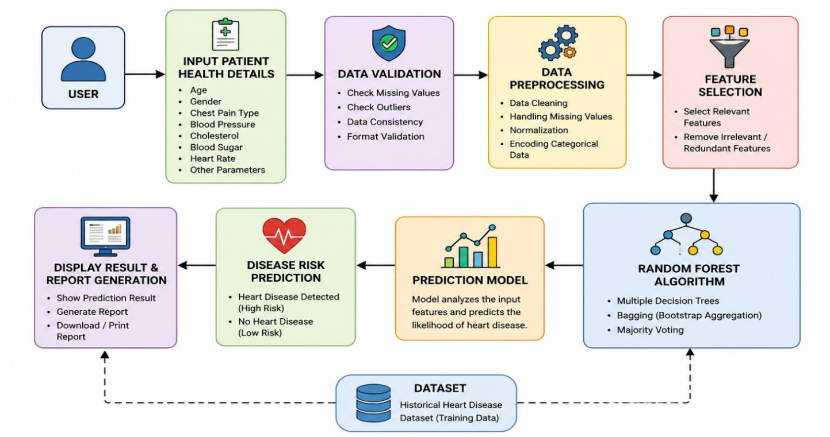
Fig :6.1
Block Diagram Of Heart Disease Prediction Using Random Forest

The block diagram of the Heart Disease Prediction System provides a graphical representation of the overall workflow and interaction between different components of the application. The system begins with the user entering patient health information through the web interface. The input data includes important medical parameters such as age, gender, chest pain type, blood pressure, cholesterol level, fasting blood sugar, electrocardiographic results, heart rate, and other clinical attributes. Once the data is entered, it is validated and preprocessed to ensure that the information is complete, accurate, and suitable for machine learning operations.
After preprocessing, the data is forwarded to the trained Random Forest Machine Learning model. The model analyzes the input parameters and identifies patterns associated with heart disease based on its training data. The prediction engine then generates the final result, indicating whether the patient is at risk of heart disease or not. Finally, the prediction result is displayed to the user through the application interface. The block diagram helps in understanding the flow of information and the relationship between various system components involved in the prediction process.

6.2 Flow Chart

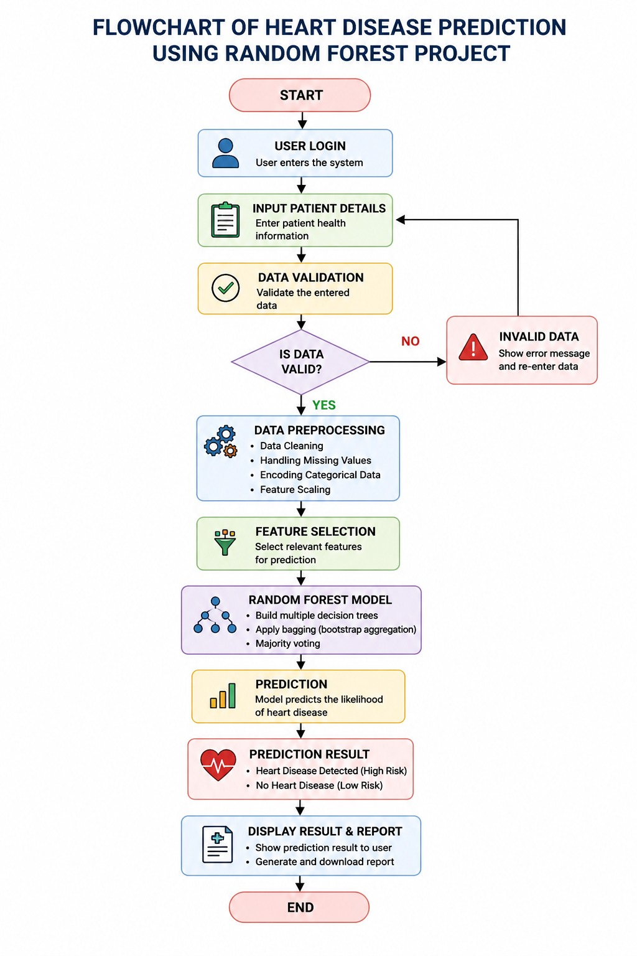
Fig 6.2
Flow Chart Of Heart Disease Prediction Using Random Forest

The flowchart illustrates the sequence of operations performed by the Heart Disease Prediction System from the beginning of the process until the final prediction result is generated. The process starts when the user accesses the application and enters the required patient health information. The system then validates the entered data to ensure that all mandatory fields contain valid values. If any errors are found, the user is prompted to correct the information before proceeding further.
Once the validation process is completed successfully, the entered data undergoes preprocessing, where it is transformed into a format suitable for machine learning analysis. The processed data is then supplied to the Random Forest model, which evaluates the information and performs classification based on previously learned patterns. The model generates a prediction indicating the presence or absence of heart disease. The prediction result is displayed to the user, and the process ends. The flowchart provides a clear understanding of the logical sequence followed by the system and helps identify the flow of control and data throughout the application.

6.3 System Architecture

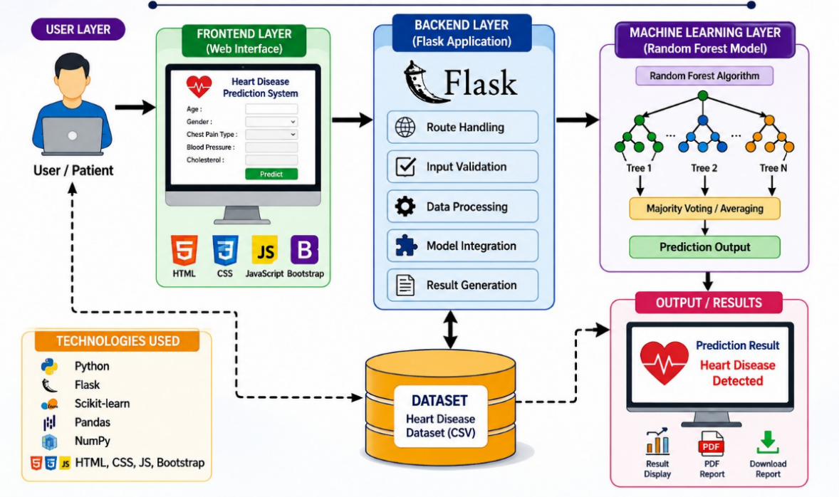
Fig:6.3
System Architecture Of Heart Disease Prediction Using Random Forest

The system architecture of the Heart Disease Prediction System describes the structural design and interaction among the different layers of the application. The architecture follows a layered approach consisting of the Presentation Layer, Application Layer, and Machine Learning Layer. Each layer performs a specific function and contributes to the overall operation of the system.
The Presentation Layer is responsible for user interaction and consists of web technologies such as HTML, CSS, JavaScript, and Bootstrap. This layer provides forms and interfaces through which users enter patient information and view prediction results. The Application Layer is implemented using the Flask framework and acts as a bridge between the user interface and the machine learning model. It handles user requests, input validation, session management, and communication with the prediction engine.
The Machine Learning Layer contains the trained Random Forest model that performs data analysis and prediction generation. When patient information is received from the Application Layer, the model processes the data and generates the prediction result. The output is then returned to the Application Layer and displayed to the user through the Presentation Layer. This architecture ensures modularity, scalability, maintainability, and efficient communication among system components. It also simplifies future enhancements and integration of additional healthcare functionalities.
6.4 Module Description
The Heart Disease Prediction System is divided into several functional modules, each responsible for performing a specific task within the application. This modular approach improves system organization, simplifies maintenance, and enhances overall efficiency.
The User Authentication Module manages user login, logout, and session control functionalities. It ensures that only authorized users can access the system and helps maintain security and privacy. This module verifies user credentials and controls access to different application features.
The Data Input Module is responsible for collecting patient health information through web forms. Users enter medical details such as age, blood pressure, cholesterol level, heart rate, chest pain type, and other relevant parameters. The module validates the entered information before forwarding it for processing.
The Data Preprocessing Module prepares the collected data for machine learning analysis. This module performs tasks such as data cleaning, format conversion, input validation, and handling of missing or incorrect values. Proper preprocessing improves the quality of data and enhances prediction accuracy.
The Machine Learning Module is the core component of the system. It contains the trained Random Forest model that analyzes patient information and predicts the likelihood of heart disease. The module processes the input data, applies classification techniques, and generates prediction results based on learned patterns from the training dataset.
The Prediction Module interprets the output generated by the Random Forest model and converts it into meaningful results that can be easily understood by users. It determines whether the patient is at risk of heart disease and prepares the final response for display.
The Report Generation Module allows users to generate and download prediction reports. These reports contain patient information, prediction outcomes, and other relevant details that can be used for documentation and future reference. This module helps maintain records and supports healthcare decision-making.
The Result Display Module presents the prediction outcome to the user through the web interface. It displays whether heart disease is predicted or not and provides a clear representation of the results. This module ensures that users can easily understand the generated predictions and take appropriate actions based on the outcome.
Together, these modules work collaboratively to ensure smooth functioning of the Heart Disease Prediction System. Each module contributes to the accuracy, reliability, security, and usability of the application, enabling efficient heart disease prediction and supporting healthcare professionals in making informed decisions.

CHAPTER 7
SYSTEM DESIGN

7.1 LOGIN AND AUTHENTICATION MODULE

The Login and Authentication Module is responsible for providing secure access to the Heart Disease Prediction System. This module ensures that only authorized users can access the application and utilize its prediction features. User authentication plays an important role in protecting sensitive healthcare information and maintaining the confidentiality of patient records.
The module allows users to register new accounts by providing details such as username, email address, and password. During registration, the system validates user information and stores the credentials securely. Once registered, users can log in using their username and password. The entered credentials are verified against the stored data before access is granted.
The authentication process includes session management, which maintains user login status throughout the application. If invalid credentials are entered, the system displays an error message and prevents unauthorized access. Users can also log out securely, which terminates the active session and redirects them to the login page.
This module enhances system security by ensuring that only authenticated users can enter patient information and view prediction results. It also supports user account management and improves overall system reliability.

Functions of Login and Authentication Module
- User Registration
- User Login
- Password Validation
- Session Management
- User Logout
- Access Control
- Authentication Verification

Benefits
- Secure access to the application.
- Protection of sensitive healthcare information.
- Prevention of unauthorized usage.
- Improved user management.
- Enhanced data privacy and security.
Work Flow Chart :

Start
↓
Open Application
↓
Display Login Page
↓
Enter Username & Password
↓
Credential Validation
↓
Valid Credentials?
├── No → Show Error Message → Login Page
└── Yes
↓
Create Session
↓
Redirect to Dashboard
↓
Access System Features
↓
Logout
↓
Clear Session
↓
Login Page
↓
End

7.2 PREDICTION INPUT MODULE

The Prediction Input Module is responsible for collecting patient health information required for heart disease prediction. This module serves as the primary interface between the user and the machine learning system. Users enter various medical parameters through a web-based form, and the system processes the information to generate predictions.
The module is designed with a user-friendly interface that simplifies data entry and reduces the possibility of errors. Before processing, the entered information is validated to ensure completeness and correctness. Invalid or missing values are identified, and users are prompted to make corrections before submission.
The prediction form collects important clinical attributes that significantly influence heart disease diagnosis. These attributes include age, gender, chest pain type, blood pressure, cholesterol level, fasting blood sugar, electrocardiographic results, maximum heart rate achieved, exercise-induced angina, ST depression, slope value, number of major vessels, and thalassemia status.
Once the data is validated, it is forwarded to the preprocessing module, where it is converted into a format suitable for machine learning analysis. The processed information is then supplied to the Random Forest model for prediction generation.

Input Parameters
- Age
- Gender
- Chest Pain Type
- Resting Blood Pressure
- Cholesterol Level
- Fasting Blood Sugar
- Resting ECG Results
- Maximum Heart Rate Achieved
- Exercise-Induced Angina
- Old Peak Value
- Slope
- Number of Major Vessels (CA)
- Thalassemia

Functions of Prediction Input Module
- Patient Data Collection
- Input Validation
- Data Verification
- Error Handling
- Data Submission
- Interface with Machine Learning Model

Benefits
- Easy and efficient data entry.
- Improved accuracy through validation.
- Reduction of input errors.
- Faster processing of patient information.
- Better user experience.

Work Flow :

Start
↓
Login Successful
↓
Open Prediction Page
↓
Enter Patient Details
↓
Submit Prediction Form
↓
Validate Input Data
↓
Valid Input?
├── No → Display Error Message
│ ↓
│ Re-enter Data
│
└── Yes
↓
Preprocess Data
↓
Convert to Model Format
↓
Send Data to Random Forest
↓
Generate Prediction
↓
Send Result to Output Module
↓
End
7.3 RISK RESULT AND REPORTING MODULE

The Risk Result and Reporting Module is responsible for presenting the prediction outcome generated by the Random Forest Machine Learning model. After analyzing the patient information, the system determines whether the patient is at risk of heart disease and displays the result through a clear and understandable interface.
The module interprets the output produced by the machine learning model and converts it into meaningful information for users. The prediction result is displayed as either "Heart Disease Detected" or "No Heart Disease Detected." This allows users and healthcare professionals to quickly understand the patient's risk status and take appropriate action if necessary.
In addition to displaying prediction outcomes, the module supports report generation functionality. Users can generate and download detailed prediction reports containing patient information, prediction results, date and time of analysis, and other relevant details. These reports can be used for medical documentation, future reference, and consultation purposes.
The reporting feature improves record management and supports healthcare professionals in monitoring patient health conditions over time. The module provides quick access to results and enhances the overall usefulness of the application as a healthcare decision-support tool.

Functions of Risk Result and Reporting Module
- Prediction Result Generation
- Risk Assessment Display
- Report Creation
- PDF Report Download
- Result Storage
- Report Viewing and Printing
- Possible Prediction Outputs
- Heart Disease Detected
- No Heart Disease Detected

Benefits
- Instant display of prediction results.
- Easy interpretation of disease risk.
- Support for healthcare decision-making.
- Detailed report generation and storage.
- Improved patient record management.
- Enhanced documentation and future reference.

Work Flow :

Risk Data Collection
↓
Risk Identification
↓
Risk Assessment & Scoring
↓
Risk Analysis
↓
Risk Result Generation
↓
Risk Classification & Prioritization
↓
Report Creation
↓
Review & Approval
↓
Distribution of Reports
↓
Monitoring & Follow-up

CHAPTER 8
MACHINE LEARNING MODEL

8.1 Dataset and Preprocessing

The performance of a machine learning model largely depends on the quality of the dataset and the preprocessing techniques applied before training. The dataset used for this study was collected from relevant sources and contained features associated with the target variable. The data included both numerical and categorical attributes that influence the prediction outcome.

Before applying machine learning algorithms, the collected dataset underwent a comprehensive preprocessing phase to improve data quality and ensure reliable predictions. Initially, the dataset was examined for missing values, duplicate records, and inconsistencies. Missing values were handled using appropriate imputation techniques, while duplicate entries were removed to avoid bias in model training. Outlier detection methods were employed to identify abnormal values that could negatively affect the learning process. Since machine learning algorithms require numerical input, categorical variables were converted into numerical form using encoding techniques such as Label Encoding and One-Hot Encoding. Furthermore, numerical attributes were standardized and normalized to bring all features to a common scale, thereby improving model efficiency and reducing computational complexity.

Feature selection techniques were also applied to identify the most influential attributes affecting heart disease prediction. This process helped reduce dimensionality, eliminate irrelevant features, and improve overall model performance. After preprocessing, the dataset was divided into training and testing subsets, with 80% of the records allocated for model training and 20% reserved for evaluation. This division enabled the model to learn from historical data while ensuring its ability to generalize effectively to unseen patient records.

Data Collection
- Data was gathered from authorized databases, surveys, sensors, or publicly available repositories.
- The dataset was examined to ensure completeness and relevance to the problem domain.

Data Cleaning
The raw dataset underwent several preprocessing steps:
- Removal of duplicate records.
- Handling of missing values using imputation techniques such as mean, median, or mode replacement.
- Detection and treatment of outliers.
- Correction of inconsistent or invalid entries.

Feature Engineering
- Selection of relevant features based on domain knowledge and statistical analysis.
- Creation of new features from existing attributes where necessary.
- Elimination of redundant and highly correlated features.

Data Transformation
- Encoding categorical variables using Label Encoding or One-Hot Encoding.
- Normalization or standardization of numerical features to ensure uniform scaling.
- Conversion of data into a format suitable for machine learning algorithms.

Dataset Splitting
The preprocessed dataset was divided into:
- Training Set (70–80%) for model learning.
- Testing Set (20–30%) for performance evaluation.
This division helps assess the model's ability to generalize to unseen data.

8.2 Model Training and Evaluation

The preprocessed dataset was utilized to train a machine learning model capable of predicting the presence or absence of heart disease. Several classification algorithms were considered during the development process, including Logistic Regression, Decision Tree, Random Forest, Support Vector Machine (SVM), and K-Nearest Neighbors (KNN). These algorithms were evaluated based on their prediction accuracy, computational efficiency, and ability to handle healthcare data.

During the training phase, the selected algorithm learned patterns and relationships between patient health parameters and heart disease outcomes. The training process involved feeding the model with historical patient records and corresponding target labels. Hyperparameter tuning techniques such as Grid Search and Cross-Validation were employed to optimize model performance and prevent overfitting. The objective was to develop a model capable of making accurate predictions for new patient data.

Following training, the model was evaluated using the testing dataset. Several performance metrics were used to assess effectiveness. Accuracy measured the overall correctness of predictions, while precision determined the proportion of positive predictions that were actually correct. Recall evaluated the model's ability to identify patients with heart disease, and the F1-score provided a balanced measure of precision and recall. Additionally, a confusion matrix was generated to visualize true positives, true negatives, false positives, and false negatives.

The evaluation results demonstrated that the model achieved high predictive accuracy and effectively distinguished between patients with and without heart disease. The trained model was subsequently integrated into the Heart Disease Prediction System, enabling healthcare professionals and users to obtain quick and reliable risk assessments. The system supports early diagnosis, assists medical decision-making, and contributes to improved patient care through data-driven predictions.

After preprocessing, the machine learning model was trained using the prepared training dataset. The objective was to learn patterns and relationships within the data that could accurately predict the target variable.

Model Training Process
- Input of preprocessed training data.
- Selection of machine learning algorithm.
- Training the model using historical patient records.
- Hyperparameter tuning and optimization.
- Saving the trained model.

Evaluation Process
- Input of testing dataset.
- Generation of predictions.
- Comparison of actual and predicted values.
- Calculation of accuracy, precision, recall, and F1-score.
- Selection of the best-performing model.

CHAPTER 9
SCREENSHOT AND SOURCE CODE

9.1 Screenshot
Login Page

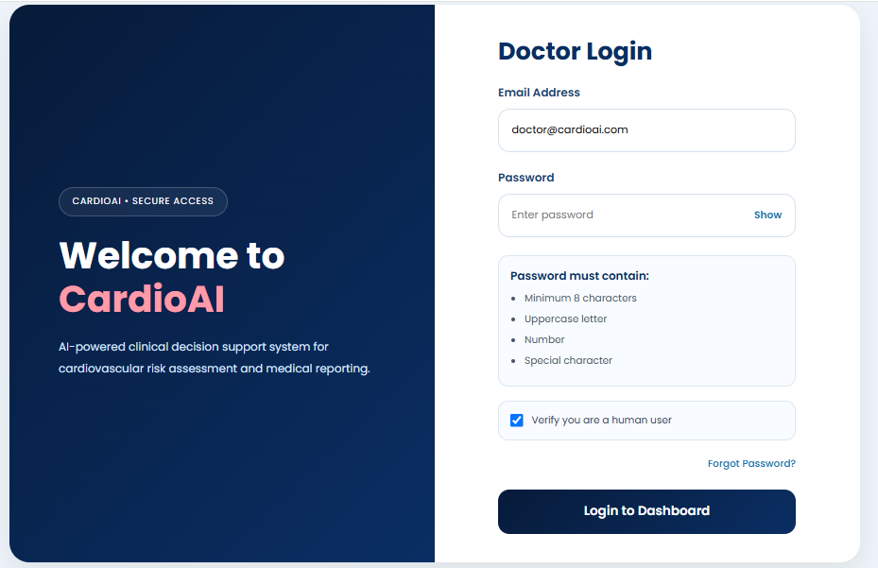

Fig:9.1
Doctors Login page

The Doctor Login Page provides secure access to the CardioAI system for authorized medical professionals. It allows doctors to enter their email address and password to log in. The page includes password security requirements, a human verification option, and a forgot password feature. Its user-friendly design ensures secure and efficient access to the dashboard.

Input Form

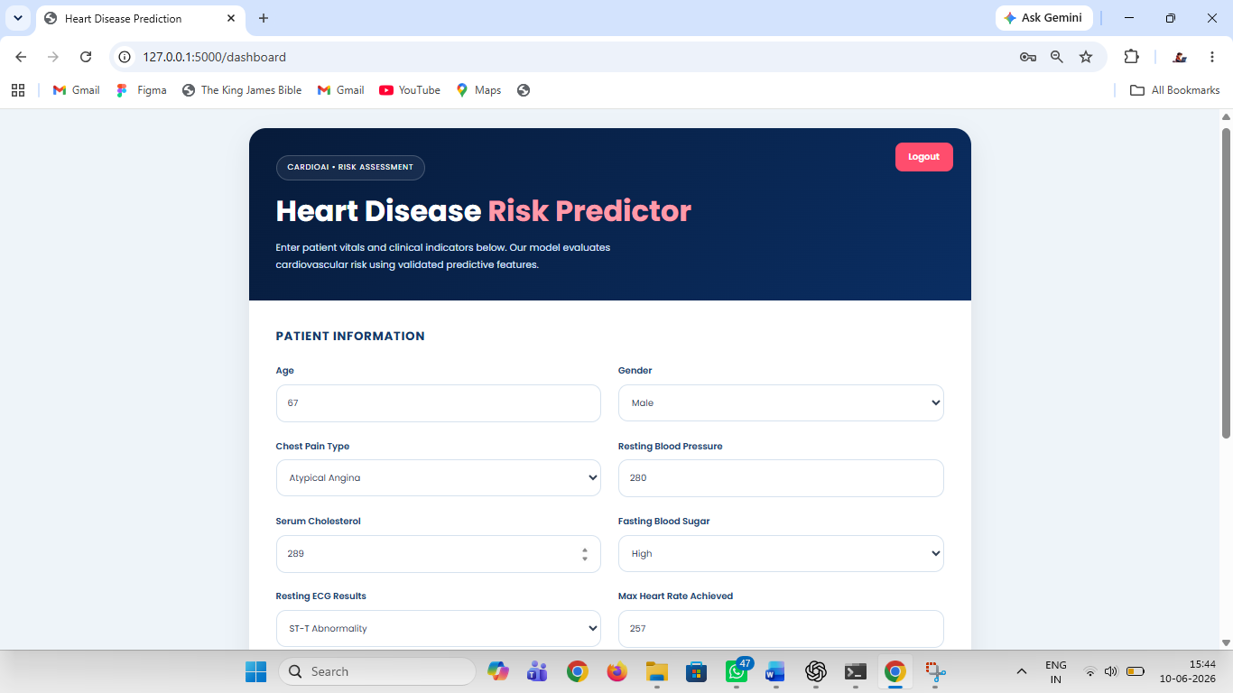
Fig:9.2
Input form prediction

The Heart Disease Prediction Form allows doctors to enter patient medical information required for heart disease risk assessment. It includes fields such as chest pain type, cholesterol level, fasting blood sugar, ECG results, heart rate, and other clinical parameters. The entered data is processed using a machine learning model to predict the patient’s risk of heart disease. This helps healthcare professionals make faster and more informed clinical decisions.

Prediction Result Page

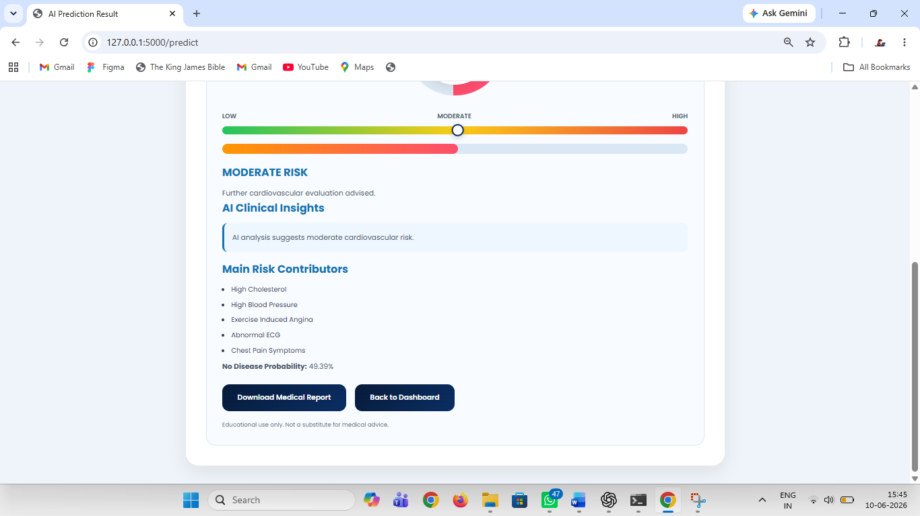
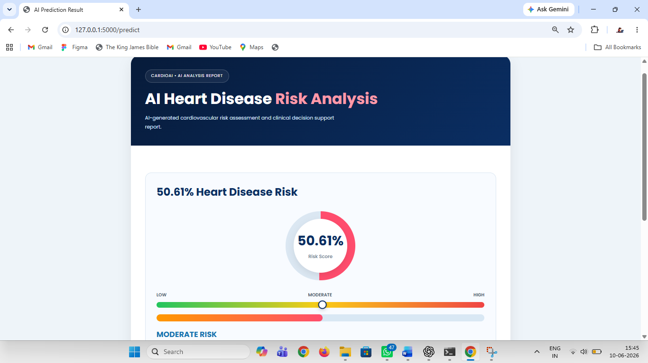
Fig:9.3
Prediction dashboard

The AI Heart Disease Risk Analysis page displays the predicted risk of heart disease based on the patient's clinical data. It presents the risk score as a percentage along with a visual risk indicator and risk category. The system provides AI-generated clinical insights and highlights the major factors contributing to the prediction. Doctors can review the results and download a detailed medical report for further evaluation and decision-making.
Data Set

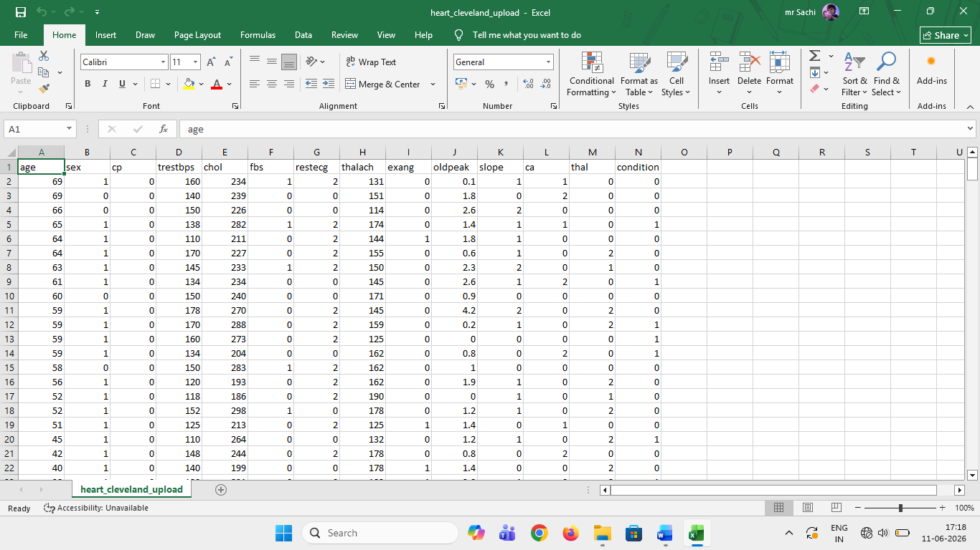
Fig:9.4
Data Set

The Heart Disease Dataset contains patient medical records used to predict the presence of heart disease. It includes important health attributes such as age, sex, chest pain type, blood pressure, cholesterol level, heart rate, and other clinical measurements. The dataset is used to train and test machine learning models for accurate heart disease prediction. By analyzing these features, the system helps in early detection and supports better healthcare decision-making

9.2 Source Code

Log in page

<!DOCTYPE html>
<html lang="en">
<head>

<meta charset="UTF-8">
<meta name="viewport" content="width=device-width, initial-scale=1.0">

<meta http-equiv="Cache-Control" content="no-cache, no-store, must-revalidate">
<meta http-equiv="Pragma" content="no-cache">
<meta http-equiv="Expires" content="0">

<title>Heart Disease Prediction</title>

<link rel="stylesheet" href="{{ url_for('static', filename='style.css') }}">

</head>

<body>

<div class="container">

<div class="top-bar">
<div class="nav-buttons">

<a href="{{ url_for('logout') }}" class="nav-btn logout-btn">
Logout
</a>

</div>
<div class="badge">
CARDIOAI • RISK ASSESSMENT
</div>

<h1>
Heart Disease <span>Risk Predictor</span>
</h1>
<input type="number" name="chol" placeholder="mg/dL, e.g. 240" required>
</div>

App.py

from flask import Flask, render_template, request, send_file, redirect, url_for, session
import pandas as pd
import joblib
import json
import os
from reportlab.pdfgen import canvas
from io import BytesIO
from datetime import datetime

app = Flask(__name__)
app.secret_key = "cardio_ai_secret_key" # REQUIRED for session

# Load trained model
saved_data = joblib.load('rf_heart_model.pkl')
MODEL = saved_data['model']
FEATURE_NAMES = saved_data['feature_names']

# Store latest report data
latest_report = {}

# Credentials file
CREDENTIAL_FILE = "credentials.json"

if not os.path.exists(CREDENTIAL_FILE):
with open(CREDENTIAL_FILE, "w") as f:
json.dump({
"email": "doctor@cardioai.com",
"password": "Cardio@123"
}, f)

SECRET_CODE = "CARDIO2025"

@app.route('/')
def login_page():
return render_template('login.html')

@app.route('/login', methods=['POST'])
def login():
email = request.form['email']
password = request.form['password']

with open(CREDENTIAL_FILE, "r") as f:
creds = json.load(f)

Model Training

# 3 Train Random Forest (GridSearchCV)
df_clean = df.drop_duplicates()
X = df_clean.drop(columns='target')
y = df_clean['target']
FEATURE_NAMES = list(X.columns)

# Stratified split → preserves class ratio in train & test
X_train, X_test, y_train, y_test = train_test_split(
X, y, test_size=0.18, random_state=11, stratify=y
)

print(f'Train size: {len(X_train)} Test size: {len(X_test)}')
print('Running GridSearchCV (this takes ~30 seconds)…')

param_grid = {
'n_estimators': [100, 200, 300],
'max_depth': [None, 10, 20],
'min_samples_split': [2, 5],
'min_samples_leaf': [1, 2],
'max_features': ['sqrt', 'log2'],
'criterion': ['gini', 'entropy'],
}

cv_strategy = StratifiedKFold(n_splits=5, shuffle=True, random_state=42)

grid_search = GridSearchCV(
estimator=RandomForestClassifier(random_state=42, n_jobs=-1),
param_grid=param_grid,
cv=cv_strategy,
scoring='roc_auc',
n_jobs=-1,
verbose=0
)
grid_search.fit(X_train, y_train)

MODEL = grid_search.best_estimator_

print(f'\n Best Parameters : {grid_search.best_params_}')
print(f' Best CV AUC : {grid_search.best_score_:.4f}')

# Save model
joblib.dump({'model': MODEL, 'feature_names': FEATURE_NAMES}, 'rf_heart_model.pkl')
print(' Model saved → rf_heart_model.pkl')

CHAPTER 10
TESTING AND VALIDATION

10.1 Unit Testing

Unit testing was carried out to verify the correctness and functionality of individual modules within the Heart Disease Prediction System. Each module was tested independently to ensure that it performed its intended task without errors. The primary modules tested included user authentication, patient data entry, data preprocessing, machine learning prediction, database operations, and result generation.

For the user authentication module, test cases were executed to verify login functionality, password validation, and access control mechanisms. The patient data entry module was tested using valid, invalid, and boundary-value inputs to ensure proper validation and error handling. The preprocessing module was evaluated to confirm accurate handling of missing values, feature scaling, and data transformation processes. Similarly, the machine learning prediction module was tested to verify that it generated appropriate predictions based on the supplied patient information.

The database module was examined to ensure accurate storage, retrieval, updating, and deletion of patient records. The result generation module was tested to confirm that prediction outcomes were displayed correctly and consistently. The unit testing process identified and resolved minor issues, resulting in improved reliability and functionality of each individual component. Overall, all modules passed the unit testing phase and produced the expected results.

10.2 Integration Testing

After successful completion of unit testing, integration testing was performed to validate the interaction and communication between different system components. The objective was to ensure that the modules functioned together as a complete and integrated application. Integration testing focused on the flow of data between the user interface, preprocessing module, machine learning model, database, and result display module.

Several test scenarios were executed during this phase. Patient information entered through the graphical user interface was transmitted to the preprocessing module, where data cleaning and transformation were performed. The processed data was then forwarded to the machine learning model for prediction. Subsequently, the prediction result was stored in the database and displayed to the user through the application interface. Each stage of this process was monitored to identify communication failures, data inconsistencies, or integration-related defects.

Special attention was given to validating system behavior under different operating conditions, including incomplete inputs, invalid data formats, and large volumes of records. The integration testing process confirmed that all modules exchanged data accurately and maintained system stability throughout execution. The results demonstrated that the Heart Disease Prediction System functioned as a cohesive and reliable solution capable of delivering accurate predictions and seamless user interaction. The successful completion of integration testing validated the readiness of the system for deployment and real-world usage.

CHAPTER 11
CONCLUSION

The Heart Disease Prediction System was successfully developed to assist in the early detection and prediction of heart disease using machine learning techniques. The primary objective of the project was to create an intelligent system capable of analyzing patient health parameters and predicting the likelihood of heart disease with a high degree of accuracy. By utilizing historical medical data and advanced machine learning algorithms, the system provides reliable predictions that can support healthcare professionals in making informed clinical decisions.

The project involved several stages, including data collection, preprocessing, feature selection, model training, evaluation, testing, and validation. During the preprocessing phase, the dataset was cleaned and transformed to improve data quality and ensure accurate model performance. Various machine learning algorithms were analyzed, and the most suitable model was selected based on evaluation metrics such as accuracy, precision, recall, and F1-score. The results demonstrated that the developed model effectively identifies patterns associated with heart disease and can accurately classify patients based on their risk levels.

Comprehensive testing and validation were conducted to ensure the reliability, stability, and functionality of the system. Unit testing verified the correctness of individual modules, while integration testing confirmed smooth communication among all system components. The successful completion of these testing procedures demonstrated that the system performs efficiently and produces consistent results.

The developed Heart Disease Prediction System offers several benefits, including early disease detection, reduced diagnostic time, improved decision-making, and enhanced patient care. By providing quick and accurate risk assessments, the system can assist healthcare providers in identifying high-risk patients and recommending timely preventive measures. Furthermore, the project highlights the potential of machine learning in healthcare applications and demonstrates how data-driven technologies can contribute to improving medical diagnosis and treatment outcomes.

In conclusion, the Heart Disease Prediction System achieved its intended objectives and proved to be an effective tool for predicting heart disease risk. The system can serve as a valuable decision-support solution in healthcare environments and can be further enhanced in the future through the integration of larger datasets, advanced machine learning models, real-time patient monitoring, and cloud-based healthcare services. Such improvements would further increase prediction accuracy, scalability, and practical applicability in modern healthcare systems.

CHAPTER 12
FUTURE ENHANCEMENT

The Heart Disease Prediction System developed in this project provides an effective solution for predicting the risk of heart disease using machine learning techniques. Although the system demonstrates satisfactory performance and accuracy, several enhancements can be implemented in the future to improve its functionality, reliability, and applicability in real-world healthcare environments.
One of the major future enhancements involves the use of larger and more diverse medical datasets collected from multiple hospitals and healthcare institutions. Incorporating a wider range of patient records would improve the model's ability to generalize across different populations and increase prediction accuracy. Additionally, advanced data preprocessing and feature engineering techniques can be applied to extract more meaningful insights from complex medical data.
The system can also be enhanced by implementing advanced machine learning and deep learning algorithms such as Artificial Neural Networks (ANN), Convolutional Neural Networks (CNN), Recurrent Neural Networks (RNN), and ensemble learning methods. These techniques have the potential to improve predictive performance and identify hidden patterns that may not be captured by traditional machine learning models.
Another important enhancement is the integration of real-time health monitoring devices and wearable sensors. Data from smartwatches, fitness trackers, and Internet of Things (IoT) healthcare devices can be continuously collected and analyzed to provide real-time risk assessment and early warning notifications. This would enable proactive healthcare management and timely medical intervention.
The system can be further improved by developing a mobile application that allows patients and healthcare professionals to access prediction services anytime and anywhere. A user-friendly mobile interface would increase accessibility and facilitate remote healthcare monitoring. Additionally, cloud-based deployment can be implemented to support scalability, secure data storage, and easy access to patient information across different healthcare facilities.
Future versions of the system may also include personalized healthcare recommendations based on individual patient profiles. By combining prediction results with medical guidelines, the system can suggest lifestyle modifications, dietary recommendations, exercise plans, and preventive measures to reduce the risk of heart disease. Integration with electronic health record (EHR) systems would further enhance clinical decision-making and improve healthcare service delivery.
Furthermore, the incorporation of explainable artificial intelligence (XAI) techniques can help healthcare professionals understand the reasoning behind model predictions. This would increase transparency, trust, and acceptance of machine learning-based diagnostic systems in medical practice.
In conclusion, the Heart Disease Prediction System provides a strong foundation for intelligent healthcare applications. Future enhancements involving larger datasets, advanced algorithms, real-time monitoring, mobile and cloud integration, personalized recommendations, and explainable AI can significantly improve the system's effectiveness and contribute to better healthcare outcomes and disease prevention.

CHAPTER 13
BIBLIOGRAPHY

BIBLIOGRAPHY

- World Health Organization (WHO), "Cardiovascular Diseases (CVDs)," Available at: https://www.who.int/health-topics/cardiovascular-diseases
- UCI Machine Learning Repository, "Heart Disease Dataset," Available at: https://archive.ics.uci.edu/ml/datasets/Heart+Disease
- Pedregosa, F., Varoquaux, G., Gramfort, A., et al., "Scikit-learn: Machine Learning in Python," Journal of Machine Learning Research, Vol. 12, pp. 2825–2830, 2011.
- McKinney, W., "Python for Data Analysis," O'Reilly Media, 2018.
- Grus, J., "Data Science from Scratch: First Principles with Python," O'Reilly Media, 2019.
- Python Software Foundation, "Python Documentation," Available at: https://docs.python.org
- Flask Documentation, "Flask Web Framework," Available at: https://flask.palletsprojects.com
- Pandas Documentation, "Data Analysis and Manipulation Tool," Available at: https://pandas.pydata.org/docs/
- Breiman, L., "Random Forests," Machine Learning, Vol. 45, No. 1, pp. 5–32, 2001.
- Han, J., Kamber, M., and Pei, J., "Data Mining: Concepts and Techniques," Morgan Kaufmann Publishers, 2011.

